Создание файла Pets

bibersun@bibersun-VirtualBox:~$ cat > Pets

Fido, Dog, 2020-01-01, Sit, Stay, Fetch

Whiskers, Cat, 2019-05-15, Sit, Pounce

Hammy, Hamster, 2021-03-10, Roll, Hide

Buddy, Dog, 2018-12-10, Sit, Paw, Bark

Smudge, Cat, 2020-02-20, Sit, Pounce, Scratch

Peanut, Hamster, 2021-08-01, Roll, Spin

Bella, Dog, 2019-11-11, Sit, Stay, Roll

Oliver, Cat, 2020-06-30, Meow, Scratch, Jump

^C

Проверка создания и наполнения файла Pets

bibersun@bibersun-VirtualBox:~$ cat Pets

Fido, Dog, 2020-01-01, Sit, Stay, Fetch

Whiskers, Cat, 2019-05-15, Sit, Pounce

Hammy, Hamster, 2021-03-10, Roll, Hide

Buddy, Dog, 2018-12-10, Sit, Paw, Bark

Smudge, Cat, 2020-02-20, Sit, Pounce, Scratch

Peanut, Hamster, 2021-08-01, Roll, Spin

Bella, Dog, 2019-11-11, Sit, Stay, Roll

Oliver, Cat, 2020-06-30, Meow, Scratch, Jump

Создание файла Pack_animals

bibersun@bibersun-VirtualBox:~$ cat > Pack_animals

Thunder, Horse, 2015-07-21, Trot, Canter, Gallop

Sandy, Camel, 2016-11-03, Walk, Carry Load

Eeyore, Donkey, 2017-09-18, Walk, Carry Load, Bray

Storm, Horse, 2014-05-05, Trot, Canter

Dune, Camel, 2018-12-12, Walk, Sit

Burro, Donkey, 2019-01-23, Walk, Bray, Kick

Blaze, Horse, 2016-02-29, Trot, Jump, Gallop

Sahara, Camel, 2015-08-14, Walk, Run

^C

Проверка создания и наполнения файла Pack_animals

bibersun@bibersun-VirtualBox:~$ cat Pack_animals

Thunder, Horse, 2015-07-21, Trot, Canter, Gallop

Sandy, Camel, 2016-11-03, Walk, Carry Load

Eeyore, Donkey, 2017-09-18, Walk, Carry Load, Bray

Storm, Horse, 2014-05-05, Trot, Canter

Dune, Camel, 2018-12-12, Walk, Sit

Burro, Donkey, 2019-01-23, Walk, Bray, Kick

Blaze, Horse, 2016-02-29, Trot, Jump, Gallop

Sahara, Camel, 2015-08-14, Walk, Run

Объединение файлов в файл Animal

bibersun@bibersun-VirtualBox:~$ cat Pack_animals Pets > Animal

Просмотр файла Animal

bibersun@bibersun-VirtualBox:~$ cat Animal

Thunder, Horse, 2015-07-21, Trot, Canter, Gallop

Sandy, Camel, 2016-11-03, Walk, Carry Load

Eeyore, Donkey, 2017-09-18, Walk, Carry Load, Bray

Storm, Horse, 2014-05-05, Trot, Canter

Dune, Camel, 2018-12-12, Walk, Sit

Burro, Donkey, 2019-01-23, Walk, Bray, Kick

Blaze, Horse, 2016-02-29, Trot, Jump, Gallop

Sahara, Camel, 2015-08-14, Walk, Run

Fido, Dog, 2020-01-01, Sit, Stay, Fetch

Whiskers, Cat, 2019-05-15, Sit, Pounce

Hammy, Hamster, 2021-03-10, Roll, Hide

Buddy, Dog, 2018-12-10, Sit, Paw, Bark

Smudge, Cat, 2020-02-20, Sit, Pounce, Scratch

Peanut, Hamster, 2021-08-01, Roll, Spin

Bella, Dog, 2019-11-11, Sit, Stay, Roll

Oliver, Cat, 2020-06-30, Meow, Scratch, Jump

Переименование файла и вывод содержимого папки

bibersun@bibersun-VirtualBox:~$ mv Animal HumanFriends.txt

bibersun@bibersun-VirtualBox:~$ ls

docker-compose.yml Pack_animals snap Документы Изображения Общедоступные Шаблоны

HumanFriends.txt Pets Видео Загрузки Музыка 'Рабочий стол'

Создание папки и перемещение туда файла

bibersun@bibersun-VirtualBox:~$ mkdir test

bibersun@bibersun-VirtualBox:~$ mv HumanFriends.txt test/

bibersun@bibersun-VirtualBox:~$ cd test

bibersun@bibersun-VirtualBox:~/test$ ls

HumanFriends.txt

установка из отдельного репозитория

<https://dev.mysql.com/downloads/>

<https://dev.mysql.com/downloads/repo/apt/>

здесь берем имя последнего пакета, затем

cd /tmp wget -c <https://dev.mysql.com/get/mysql-apt-config_0.8.29-1_all.deb>

ls -fla | grep mysql

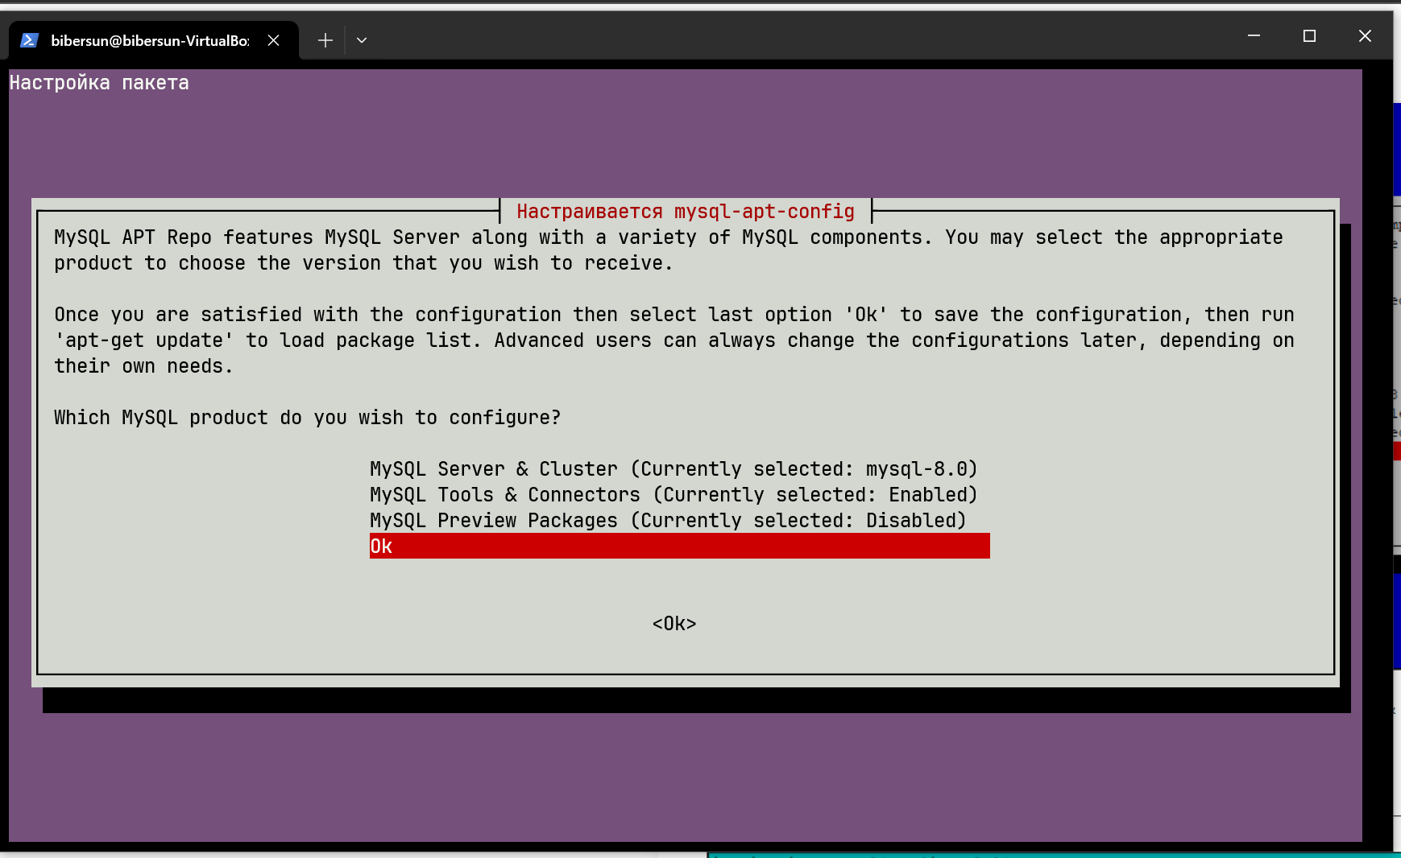проверим

bibersun@bibersun-VirtualBox:/tmp$ cd

bibersun@bibersun-VirtualBox:~$ cd /etc/apt/sources.list.d/

[bibersun@bibersun-VirtualBox](mailto:bibersun@bibersun-VirtualBox):/etc/apt/sources.list.d$

sudo nano mysql.list

содержимое:

GNU nano 6.2 mysql.list ### THIS FILE IS AUTOMATICALLY CONFIGURED ###

# You may comment out entries below, but any other modifications may be lost.

# Use command 'dpkg-reconfigure mysql-apt-config' as root for modifications.

deb [signed-by=/usr/share/keyrings/mysql-apt-config.gpg] http://repo.mysql.com/apt/ubuntu/ jammy mysql-apt-config

deb [signed-by=/usr/share/keyrings/mysql-apt-config.gpg] http://repo.mysql.com/apt/ubuntu/ jammy mysql-8.0

deb [signed-by=/usr/share/keyrings/mysql-apt-config.gpg] http://repo.mysql.com/apt/ubuntu/ jammy mysql-tools

#deb [signed-by=/usr/share/keyrings/mysql-apt-config.gpg] http://repo.mysql.com/apt/ubuntu/ jammy mysql-tools-preview

deb-src [signed-by=/usr/share/keyrings/mysql-apt-config.gpg] http://repo.mysql.com/apt/ubuntu/ jammy mysql-8.0

далее

sudo apt-get update

sudo apt-get install mysql-server (по дороге вводим пароль для рута)

установка nginx

sudo apt update

sudo apt upgrade

sudo apt-get download nginx

sudo dpkg -i nginx_1.18.0-6ubuntu14.4_amd64.deb — не хватает пакетов

sudo apt install nginx-core nginx-full nginx-light nginx-extras — добавляем отсутствующие пакеты

sudo apt --fix-broken install — фиксируем ошибки

удаление nginx

sudo apt-get purge -y nginx

sudo apt autoremove